Test Requisition Form测试申请表 |  |  |  |  |  | Quotation报价： | Yes 是 No 否
Company Name & Address of Application 申请公司名称/地址 |  |  |  |  |  |  | Official Use Only本司专用
Name 申请公司（中文）:  Name 申请公司（英文）: |  |  |  |  |  |  | Job No.
Address 地址: | E-mail 电邮: |  |  |  |  |  | Quo. No.
Contact Person 联络人: | Dept.部门/科组: |  |  |  |  |  | Receipt Date.
Telephone 电话 : | Fax 传真: |  |  |  |  |  | Received By:
Name and address of the report header (if different from the applicant)报告抬头（如与上述不同） |  |  |  |  |  |  | TAT:
Name and address of ”invoice to” Company (if different from the applicant)发票寄收（如与上述不同）
Following product information will be shown on Test report, please delete whichever is inappropriate.以下数据将显示在报告上, 请选择填写
If retest, pls specify previous report No..若为重测，请注明前次测试报告号 :
Sample Description样品描述 :
Buyer 买家 :
Order No.订单编号 : |  |  |  |  | Qty of Sample Submitted 样品数量 :
Manufacturer 制造商 /Supplier 供货商: |  |  |  |  | Goods Exported to 入口国 :
Request Age Grading测试年龄: |  |  |  |  | Country of Origin 原产地 :
Test(s) Required : (Please tick appropriate boxes) 测试项目名称 (请在适当空格内 “X”)
US ASTM F963 美国玩具安全标准  Physical and Mechanical 物理和机械测试  Flammability Test易燃性能测试  Heavy Metals Test 重金属元素测试  US CPSIA 2008 美国消费品安全改进法案  Lead Content in Paint (CPSC-CH-E1003-09.1) 涂层总含铅量  Lead Content in Substrate (CPSC-CH-E1001-08.3/E1002-08.3) 基材总含铅量  Phthalates Content (CPSC-CH-C1001-09.4)邻苯二甲酸盐含量  Canada Toys Regulations SOR/2011-17加拿大玩具安全标准  Physical and Mechanical 物理和机械测试  Flammability Test易燃性能测试  Heavy Metals Test 重金属元素测试  GB 6675 中国国家玩具安全标准  GB 6675.2 Physical and Mechanical 物理和机械测试  GB 6675.3 Flammability Test易燃性能测试  GB 6675.4 Heavy Metals Test 重金属元素测试  HM客户测试  HM总Pb测试 (CPSC-CH-E1003/ E1001-08.3/E1002-08.3)  Hallmark物理和機械測試(ASTM F963/SOR/2011-17)  HM Protocol-8 Phthalates測試 (CPSC-CH-C1001-09.4) |  | European Standard欧洲安全标准  EN71 Part 1 - Physical and Mechanical 物理和机械测试  EN71 Part 2 - Flammability Test易燃性能测试  EN71 Part 3 - Heavy Metals Test毒性元素测试  Total Cadmium Content-REACH (IEC62321-5)总镉含量测试  Phthalates Content- REACH (ISO 8124-6) 邻苯二甲酸盐  PAHs Tesr-REACH (AfPS GS2019:01 PAK) 多环芳烃  International Standard ISO 8124国际玩具安全标准  ISO8124-1物理和机械测试  ISO8124-2易燃性能测试  ISO8124-3毒性元素测试  Other Test: 其他测试  94/62/EEC包装材料毒性元素测试(IEC62321-4&5)  MAT AT AAT 环境测试  ISTA 国际运输安全测试(1A 1B 1C 1D 2A 2B)  BS7272書寫及標記用具的安全筆套  18phthalate content 18种邻苯二甲酸盐(ISO 8124-6)  Formaldehyde甲醛测试(样品要用外包铝箔的包装袋密封(纺织品ISO 14184-1 /GB/T2912.1, 纸EN645+EN1541, 皮革ISO 17226-2 聚合物EN71-10&11)
Other Tests (Please Specify) 其他测试（请注明) :
Decision Rule 判定规则:

When statements of conformity are required, MTS will will consider the impact of measurement uncertainty as calculated by MTS except designation from the the customer, regulations or test specifications. If the measurement result is close to the prescribed limit and withthin the inconclusive zone, only the measurement result and the value of measurement uncertainty data will be provided in the report. No conformity judgement will be provided.
要求作出符合性判定时,MTS将考虑本实验室计算的测量不确定度影响。客户、法规或标准规范中已规定了判定规则的除外。如果测量结果接近规定限值,报告中只提供测量结果及其测量不确定度数据,不做符合性判断。
Service Required: Regular(5/7 working days ) Express(4 working days) Shuttle(2 working day)
(服务种类 ) (常规：5/7个工作日) (加急：4个工作日) (特快：2个工作日)
+40% Surcharge(加收40%费用) +100% Surcharge(加收100% 费用)
Return Sample是否归还样品： Yes (是) No (否)  CNAS Report (only applicalbe for accredited items仅适用认可项目) Yes(是) No (否)  Chinese Report 是否需要中文报告： Yes (是，每份加收RMB100) No (否) |  |  |  | Confidential保密要求: Yes (需保密) No (無需保密)  Hard Copy是否需要正本报告及发票(如无选择默认为不需要，报告接收方承担邮资)：Yes (需要) No (不需要)
We request for the above tests and agree that all testing will be carried out subject to HESHAN LEO METROLOGY AND TESTING SERVICES Co. LTD.’ scale of charges as set forth in their price list of which we have seen a copy.
(我们要求进行以上测试，并将依照鹤山利奥计量测试服务有限公司所制定的统一价目表来付费.)
Please finish the application form exactly, it will be charged if revise the test report after the report be finished.*以上数据请确实填写，报告完成后如需修改报告内容，将收取报告修改费，  Date 日期 : __________Year年 ˍˍˍˍˍˍMonth月ˍˍˍˍˍDay 日 |  |  | 公司盖章及代表签名 :  Authorized Signature  and Company Chop of the Applicant
Notes(备注) 1. To avoid any delay, the applicant should fill the test requisition form clearly.(为避免延误测试时间，请申请者清楚明了地填写此申请表)
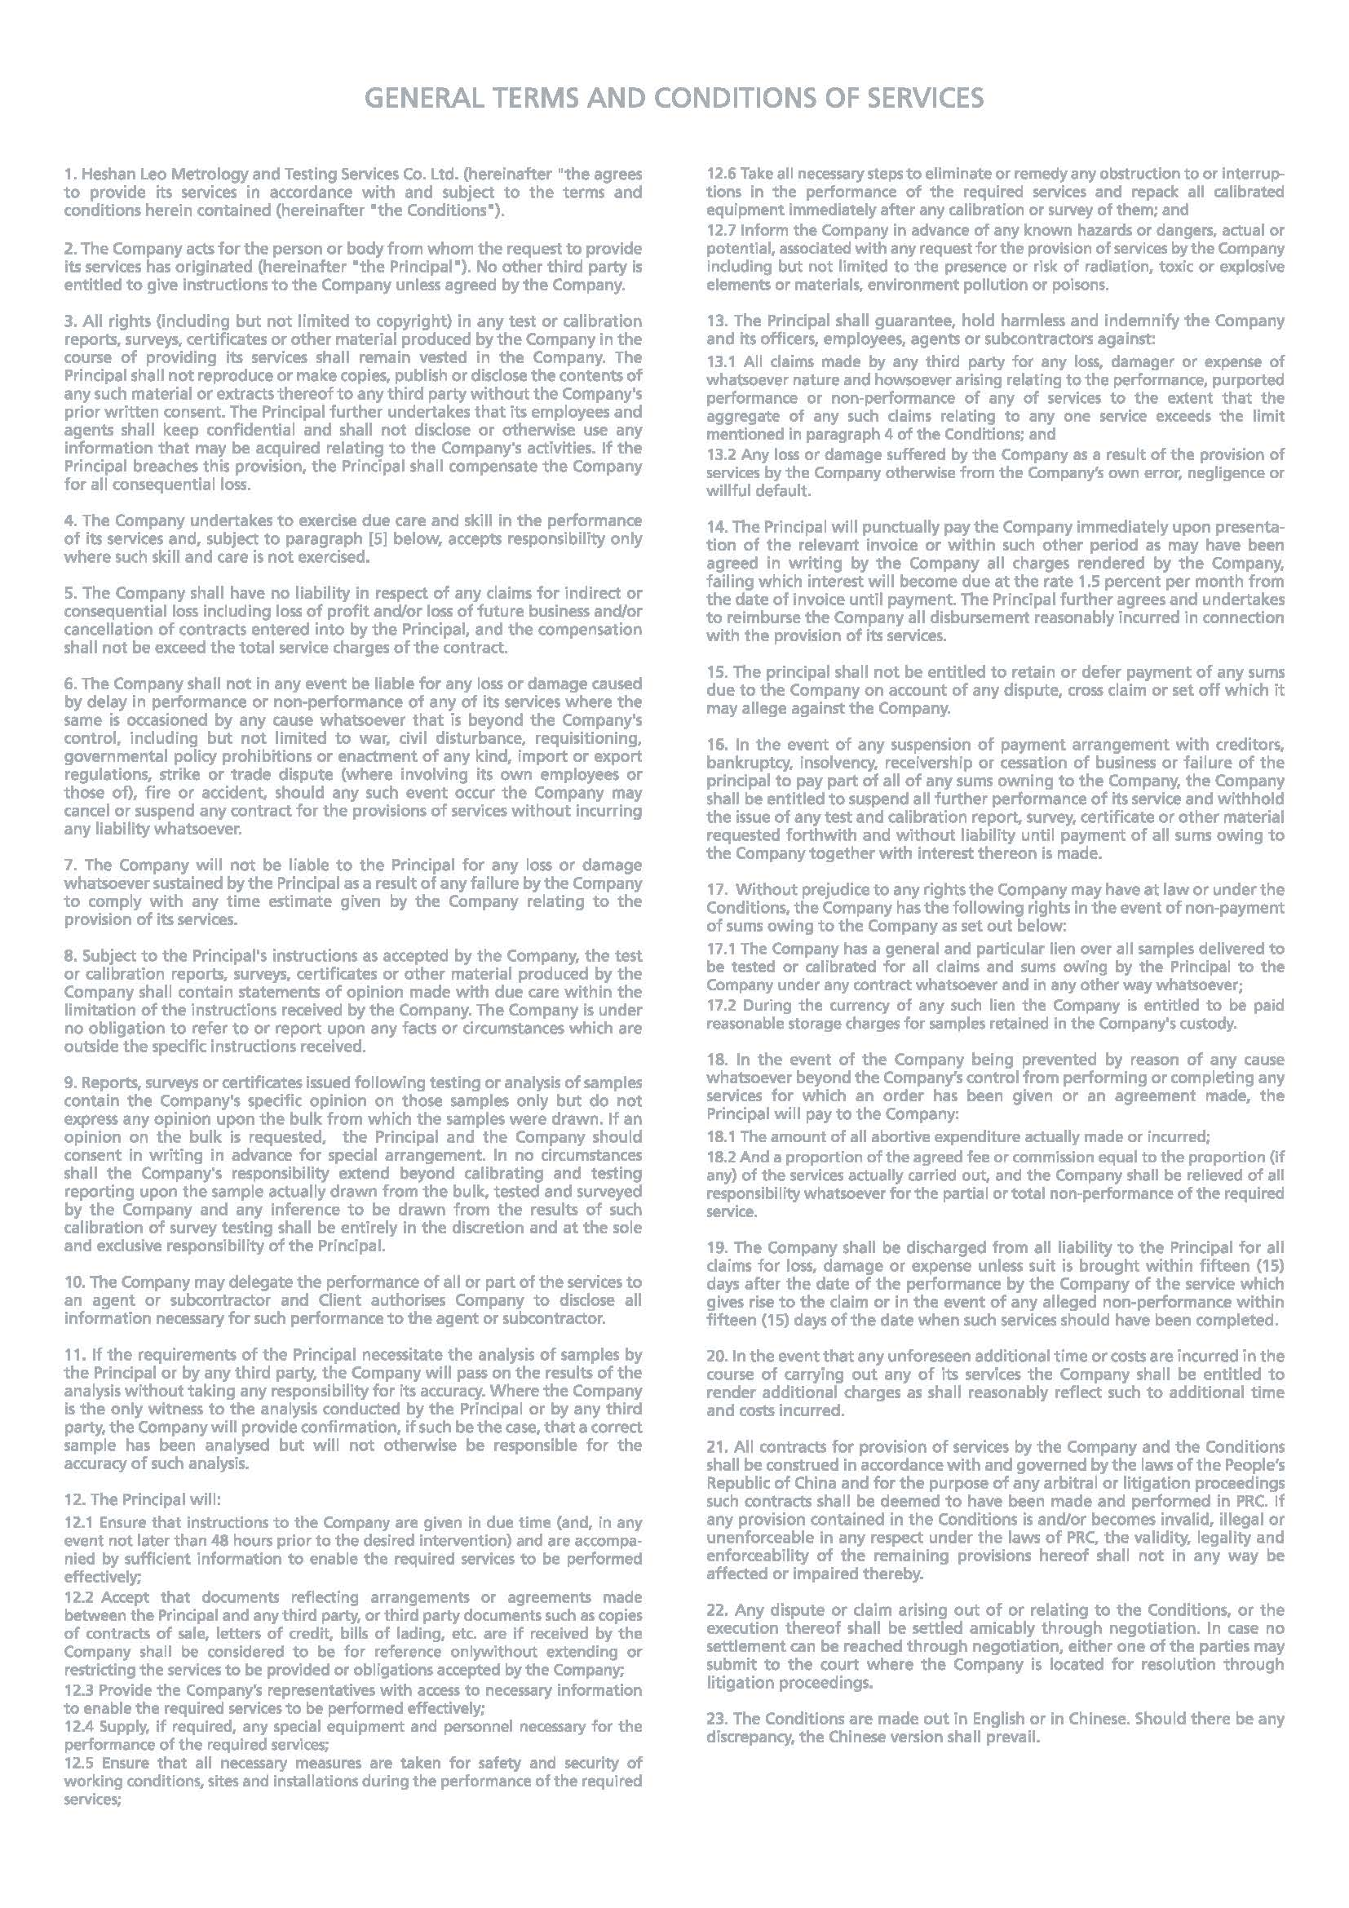
2. There is a minimun charge of RMB100.00 per report issued. (每份测试报告的最低收费是100.00元人民币)

